Door Assembly Exercise
In this exercise, we will use the List Rules function to create an initial version of a class definition file.

Step 1
Set up the Knowledge Fusion search directories.
- Choose Preferences->Knowledge Fusion.
- Enter the path to an existing folder in the New Directory box.
- Choose 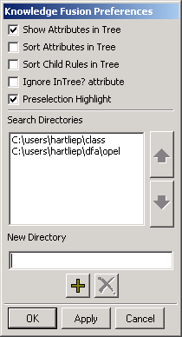.
- Choose OK.

Step 2
Retrieve door.prt (created in the Introductory Course) and list the Knowledge Fusion rules in the listing window.
- If door.prt is not open, retrieve this part and open the KF Navigator.
- Choose Preferences->Knowledge Fusion.
- Turn off Sort Attributes in Tree. Choose OK.
- Choose View->Knowledge Fusion Navigator.
- Hover the cursor over root and click MB3. Choose List Rules.

Step 3
Edit the rules in the listing window and save to a class definition (dfa) file.
- Remove first blank line.
- Change New_Class_Name to door_assy.
- Choose File->Save As…
- Go to the folder specified in Step 1.
- Enter door_assy.dfa.
- Choose OK.

Step 4
Test the design.
- Choose File->New. Enter door_assy in the File name box. Accept Units as inches. Choose OK.
- From the graphics window, click MB3. Choose Replace View->TFR-TRI.
- Choose View->Knowledge Fusion Navigator.
- Hover the cursor over root and click MB3. Choose Reload All.
- Hover the cursor over root and click MB3. Choose Add Child Rule.
- In the Name box, enter my_door.
- In the Class list, select door_assy.
- Choose OK.

- Hover the cursor over my_door and click MB3. Choose Edit.
- Choose any parameter from the Input Parameters box.
- Change the rule in the Rule for Parameter box.
- Choose Apply.
- Repeat steps 10-12 for height, width, thickness, position, window?.
NOTE: When referencing another attribute of the same instance in the rule for an input parameter, you need to use child:<attribute>. For example, to change the rule for the width input parameter, you must enter .6*child:height:.

